RAS Application Suite: Phase 5 Summary
Brian Chiasson and Dan Buhrman
This document provides a summary of the development activities for Phase 5 of the RAS development process. The document also outlines any changes to the previous project documentation as well as any new challenges that have arisen.

Milestones
The goal for Phase 5, as outlined by the Project Plan document, and carried over from previous phases are:
- Add ability to search for consumer goods recalls.
- Add any final touches.
- Fix any bugs.

Item 1 – Consumer Goods Recalls
The field to add a generic search term was added. This enables the user to search for pretty much anything, however, is still limited to Search USA's data.
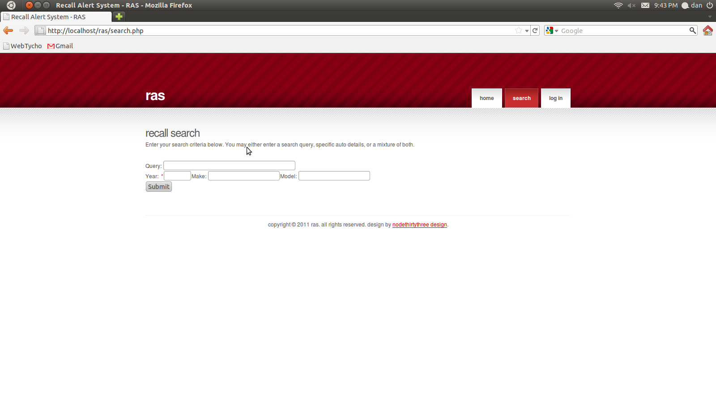Illustration 1: Final Search Form

Item 2 – Final touches

Item 2.1 – Results Pagination
Until this point, only the first 10 results where displayed to the user. This is due to a limitation with Search USA's API, in which only 10 results at a time can be returned. To remedy this, the search results are now paged in groups of 10, and allow the user to move from page to page, running a new query with each page turn.
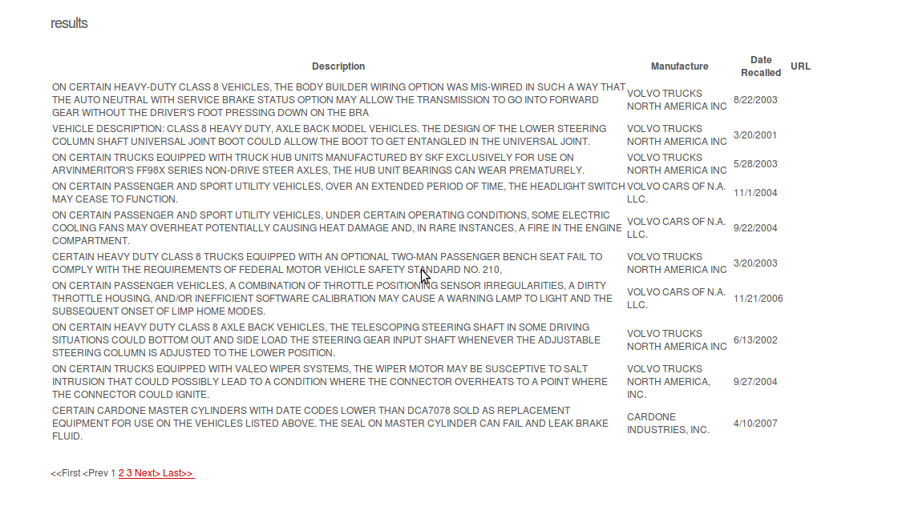Illustration 2: Pagination

Item 2.2 – Better descriptions
More interesting descriptions where added to the search form and results. There is now a brief explanation on how to use the search form at the top (see Illustration 1). Also, if no search results are returned, an explanation of possible reasons is listed. (see Illustration 3)
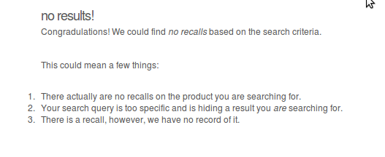Illustration 3: No Results

Item 3 – Bug Fixes
Although there where no bugs to fix, a bug was discovered in the 11th hour of Phase 5: Only search queries with a year render results. If a phase 6 existed, this would definitely be fixed in the next phase, and most definitely will be fixed if the site ever goes live to the public, however, a quick and dirty remedy was applied for now: the year field is now required.

Document Changes/Schedule Changes
We have adjusted the Project Plan's deliverables to reflect the move of the membership scripting to Phase 4. The updated chart is displayed below. It should be noted that pushing the scripting to Phase 4 has impacted Phase 5 and makes it official that the development team will not be able to get to the notifications system.

Deliverable | Date
Project Plan | 6/19
Meeting Notes | 6/20
System & Software Specification | 6/26
Meeting Notes | 6/27
Test Plan & User Guide | 7/3
Meeting Notes | 7/4
Design | 7/10
Meeting Notes | 7/11
Hosted Website (Phase 1)  Provide a hosted webpage with the ability to search for automotive recall data. | 7/17
Meeting Notes | 7/18
Membership Feature (Phase 2)  Complete website template. Enhance the website by adding a membership feature. | 7/24
Meeting Notes | 7/25
Food Recalls (Phase 3)  Complete membership control scripting. Configure SMTP server. Enhance the website by adding the ability to search for food recall data. | 7/31
Meeting Notes | 8/1
Consumer Goods Recalls (Phase 4)  - Finish member registration  - Complete SMTP server setup  - Complete membership activation  - Complete membership login  - Complete the recall search form  - Enhance the website by adding the ability to search for consumer goods recall data. | 8/7
Meeting Notes | 8/8
Touch-ups (Phase 5)  - Enhance the website by adding the ability to search for consumer goods recall data.  - Include any bug fixes, touch-ups, and any other enhancements agreed upon. | 8/14
Meeting Notes | 8/15
Final Report | 8/21
Table 1-1: Updated Project Deliverables

Retrospective
Overall, I think it is safe to say this project put a lot of stress on all team members. As one kept dropping off the map, and adding stress to others to complete the work assigned to said team member. We would hope in a real work environment, this would result in disciplinary action of some kind, and push the project back. However, in a classroom environment, 13 weeks is all the time allocated, and therefore creates the difficulty of dealing with such issues.
Also, 5 weeks of development is kind of short to take on a project of the magnitude we originally envisioned.
Overall, it was a satisfying journey, and a relief to have the burden of tight schedules ended.

